Colour Contrast Audit

Context
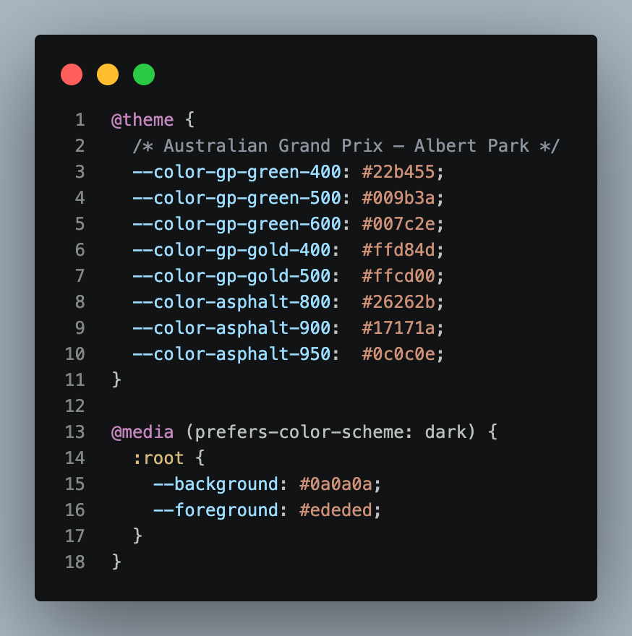
[Implemented Colour Styles Code Snippet taken from “globals.css”]
These ten colours are what have been implemented by the developers and can be categorised into four families so to speak; main (foreground and background), primary (asphalt), primary accent (green), secondary accent (gold).

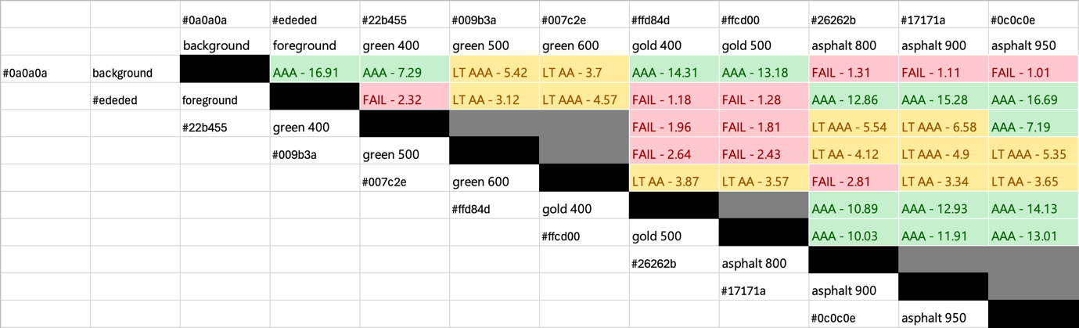
[Colour Contrast Ratio Match-Up Matrix Coloured by WCAG Rating]
[Contrast Ratios were Calculated with Adobe’s Color Contrast Analyzer]
Colours were not compared against themselves (black cells) nor colours within their own families (grey cells) with the exception of the main family (foreground and background) as unlike with the other three families, these two colours regularly interact directly with each other.

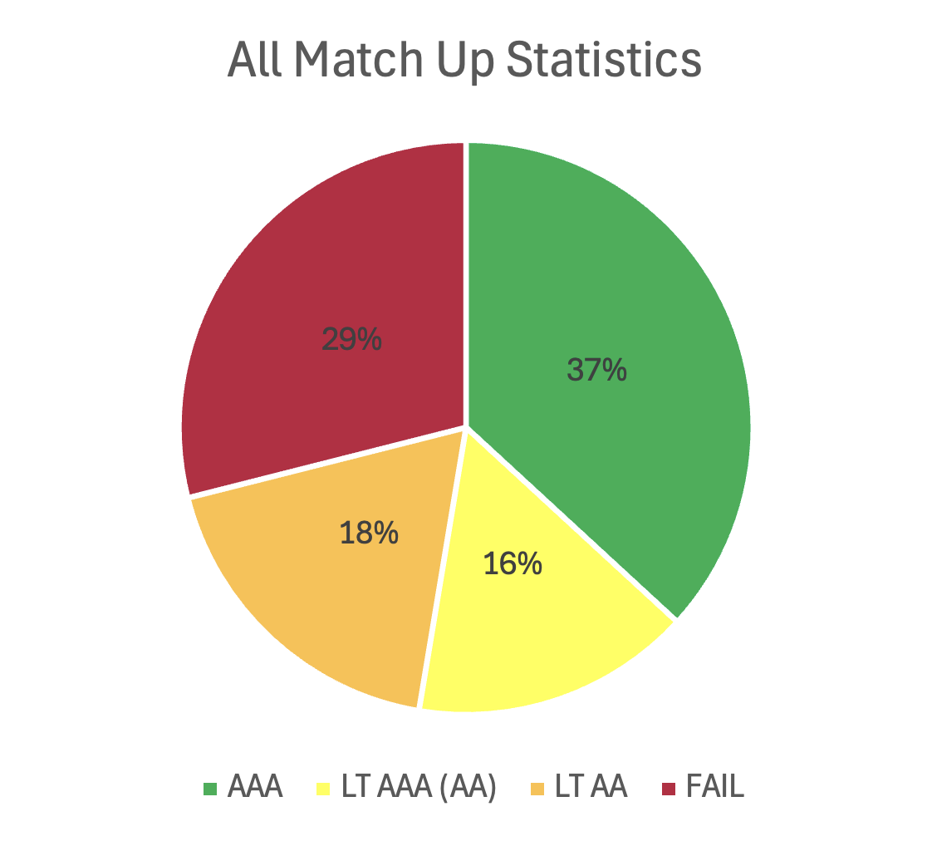
[Colour Contrast Ratio Match-Up Pie Chart Coloured by WCAG Rating]

Definitions
Version 2.2 of the Web Content Accessibility Guidelines (WCAG) defines the following contrast ratio text requirements for each rating. And where Adobe defines the following for small and large text.

AAA
- At least 7:1 for small text
- At least 4.5:1 for large text

AA
- At least 4.5:1 for small text
- At least 3:1 for large text

Small Text
- Refers to 17pt and below for regular font-weight, or 13pt and below for bold font-weight

Large Text
- Refers to 18pt and above for regular font-weight, or 14pt and above for bold font-weight

Analysis
Most regulations outline that WCAG AA is the standard to be met with WCAG AAA being exceptional. Following this, our site’s current colour scheme matrix match-up results in a 53% pass rate from combining the weights of AAA and LT AAA (AA). LT AA (Large Text AA) does not count as it fails the AA contrast requirement for small text.
However, it is worth noting that the matrix is inherently biased to produce lower pass rates even when removing matchups within the same colour families. This is because, for example, no colours in the gold family are ever used to back the foreground colour (both of these matchups fail). Similarly, the asphalt family failing against the background is less significant than it seems as asphalt is used to containerise comprehension of certain chunks of information and is not essential to reading what is displayed on screen.

[DOCUMENT CONTINUES ON NEXT PAGE]

Main Ticket Screens

Browse Tickets

All elements of this screen pass WCAG AAA standards except for the containing boxes of each ticket element which fails to meet AA requirements.

Ticket Details
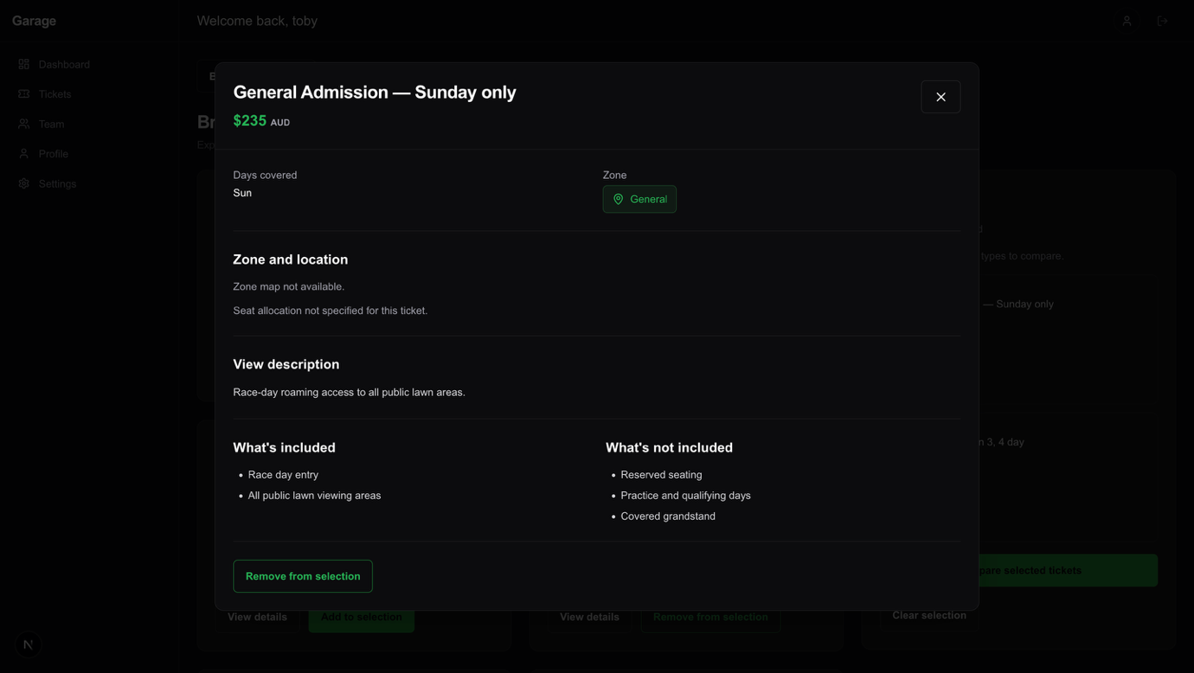
All elements of this modal pass WCAG AAA standards.

Compare Tickets
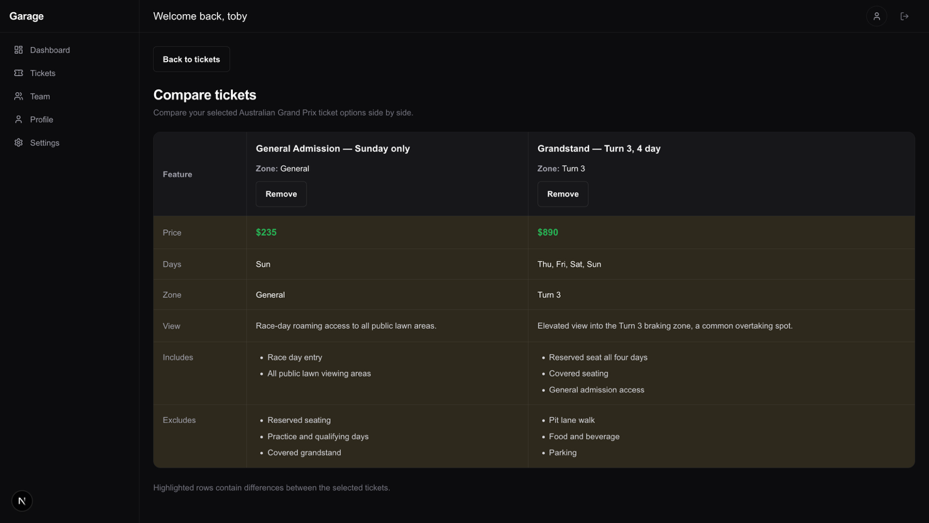
All elements of this modal pass WCAG AAA standards. Notably, even though the matchup between foreground and the gold family resulted in two contrast failures, the gold here is used at a reduced opacity meaning it inherits more of the darker background behind it; resulting in passing AAA without issue.

